CHILDREN’S SHAKESPEARE FESTIVALS

Photography and Data Collection Consent Form

Event: The Children’s Shakespeare Festivals 2025 at The New Vic Theatre
School: _________________________________________________

Date of Performance: ________________________________

Dear Parent/ Carer,

We are delighted that your child’s class is taking part in The Children’s Shakespeare Festival this year. The Children’s Shakespeare Festivals are produced by North West Drama (NWD), working in partnership with the New Vic Theatre and your child’s school.

During the performance day our professional photographer takes photographs of each class on stage, and we also print the children’s names in a programme which can be purchased on the day as a keepsake.

You have every right to withhold your consent for either of the above (you will be asked to give your consent on the next page), but it is worth remembering:

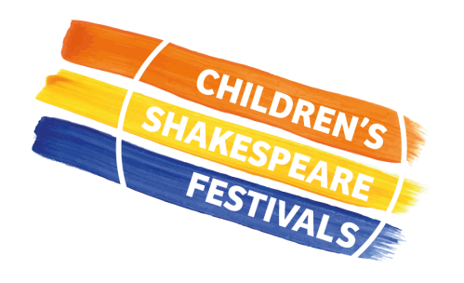
- We take photographs to celebrate the children’s participation in the project. We sometimes talk about the project on our social media channels and photographs really help to give a sense of what happens. Sometimes with local press. We never print names of children alongside a photograph or identify the school they are from.

- We print children’s names in a programme to celebrate the children’s hard work and to give them a sense of pride in having done their performance. We will only print your child’s name in the festival programme with your expressed consent.

- What will happen if you withhold permission for your child to have photographs taken? We do not take individual photographs of children, so our photographer will take photographs of the whole class on stage during their rehearsal (no audience will be present), but we will then send the photographs to their class teacher before deleting them from our system. We will NEVER use a photograph unless has permission for us to do so.

Please complete yours and your child’s details below:
Name of child ……………………………………………………………………….. Age ………

Your relationship to child …………………………………………………………………………

Signature…………………………………………… Date………………………………………

Print your name ……………………………………………………

Now please complete the other side of this form.

Please indicate your consent by ticking each statement below.
I give permission for North West Drama to take photographs or film footage that may include my child. I understand the images/ footage may be used as follows:
to record my child’s participation in an activity
to share with me as their parent/carer or other parents/carers of children involved in the project
to include in a programme
to add to North West Drama’s images archive
to include in North West Drama’s promotional materials; in print or online
for use on North West Drama’s social media platforms
for use for fundraising activity, including sharing with sponsors and supporters
to include in North West Drama’s public displays or exhibitions
by our partner theatres in their own print or online promotional materials

I give permission for my child’s school to share my child’s name with North West Drama so that they can print it in the performance programme, and for this to be stored for one year:
I give consent for my child’s name to be printed in the performance programme

HOW DO WE PROTECT DATA?
North West Drama recognise our responsibility to ensure the safety of the children and young people with whom we work. We will never ask for data that we don’t have a specific need for, and it will always be stored on NWD owned equipment and will only be accessible to NWD staff.

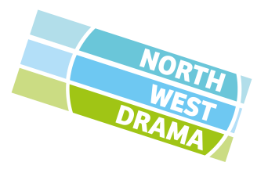
We will take all reasonable steps to ensure data is used solely for the purpose intended. You have the right to withdraw your consent at any time. If you wish to do so please contact our creative producer, Matt Wardle: matt@northwestdramaservices.co.uk

Please return this form, once complete, to your child’s teacher.
Thank you.

