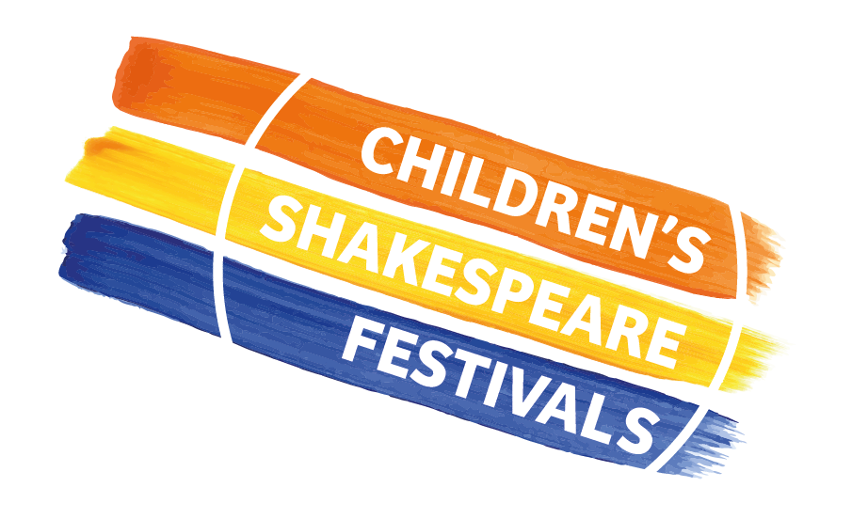
CHILDREN’S SHAKESPEARE FESTIVALS

Collated Pupil Consent and Teacher Consent Form

Event: The Children’s Shakespeare Festival 2026 at The New Vic Theatre
*Please complete one form for EACH participating class*
Name of teacher ………………………………………………………………………..

School: ………………………………………………………………………..
Signature…………………………………………… Date………………………………………

Please confirm parental/guardian consent to take photographs or to film your pupils during the festival, and for confirmation of consent for us to print your pupils’ names in the performance programme.

If you are unable to confirm consent for every participating member of your class, please tick the statement in CAPITALS, and Matt will contact you directly to discuss any specific issues.

Please confirm that you have full consent in each instance by ticking the statement and leaving it blank if you haven’t. If you haven’t got full consent for any statements please tick the last statement (in bold)

I have permission on behalf of all participating pupils, for North West Drama to take photographs of or film my class and to store these for five years. I have consent for them to be used as follows:
to record my child’s participation in an activity
*if this box is not ticked for any member of your class/ group please discuss this with Matt
to share with me as their parent/carer or other parents/carers of children taking part in the project
to include in a programme or other similar publication
to add to North West Drama’s images archive
to include in North West Drama’s promotional materials; in print or online
for use on North West Drama’s social media platforms
for use for fundraising activity, including sharing with sponsors and supporters
to include in North West Drama’s public displays or exhibitions
by our partner theatres in their own print or online promotional
for use in media print or online platforms

I DO NOT HAVE PERMISSION FOR ANY OF THE ABOVE FOR EVERY PARTICIPATING MEMBER OF MY CLASS

I have permission on behalf of all of participating pupils, for the school to share my child’s name with North West Drama so that it can be printed in the performance programme, and for this to be stored for one year:
I have consent for my class’s names to be printed in the performance programme

I DO NOT HAVE PERMISSION FOR THE ABOVE FOR EVERY PARTICIPATING MEMBER OF MY CLASS

Now please complete the following section giving YOUR consent

I give permission for North West Drama to take images of or film me, and to print my name in a performance programme. I understand the images and data may be used as follows (if you give consent to all please tick the final bold statement):
to record my participation in the Children’s Shakespeare Festival
to share with parents/carers of children involved in the project
to include in a programme or other similar publication
to add to North West Drama’s images archive
to include in North West Drama’s promotional materials; in print or online
for use on North West Drama’s social media platforms
for use for fundraising activity, including sharing with sponsors and supporters
to include in North West Drama’s public displays or exhibitions
by our partner organisations in their own print or online promotional materials.

I give consent for all of the instances listed above.

HOW DO WE PROTECT YOUR DATA?
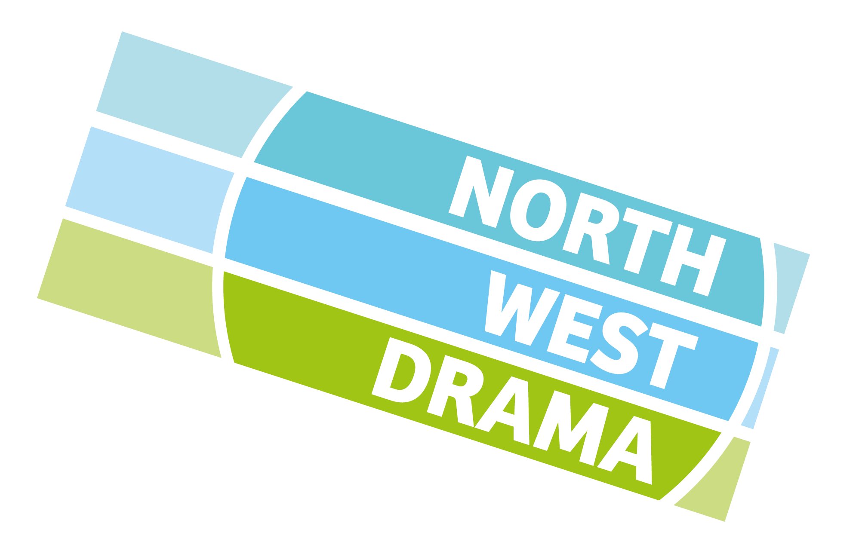
North West Drama will never ask for data that we don’t have a specific need for, and it will always be stored on NWD owned equipment and will only be accessible to NWD staff. We will take all reasonable steps to ensure data is used solely for the purpose they are intended. You have the right to withdraw your consent at any time. If you wish to do so please contact matt@northwestdramaservices.co.uk

Please return the completed form to matt@northwestdramaservices.co.uk

